Spring security :

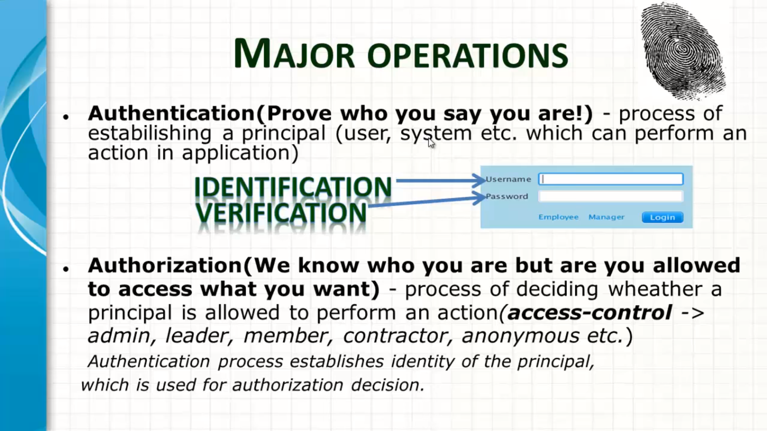

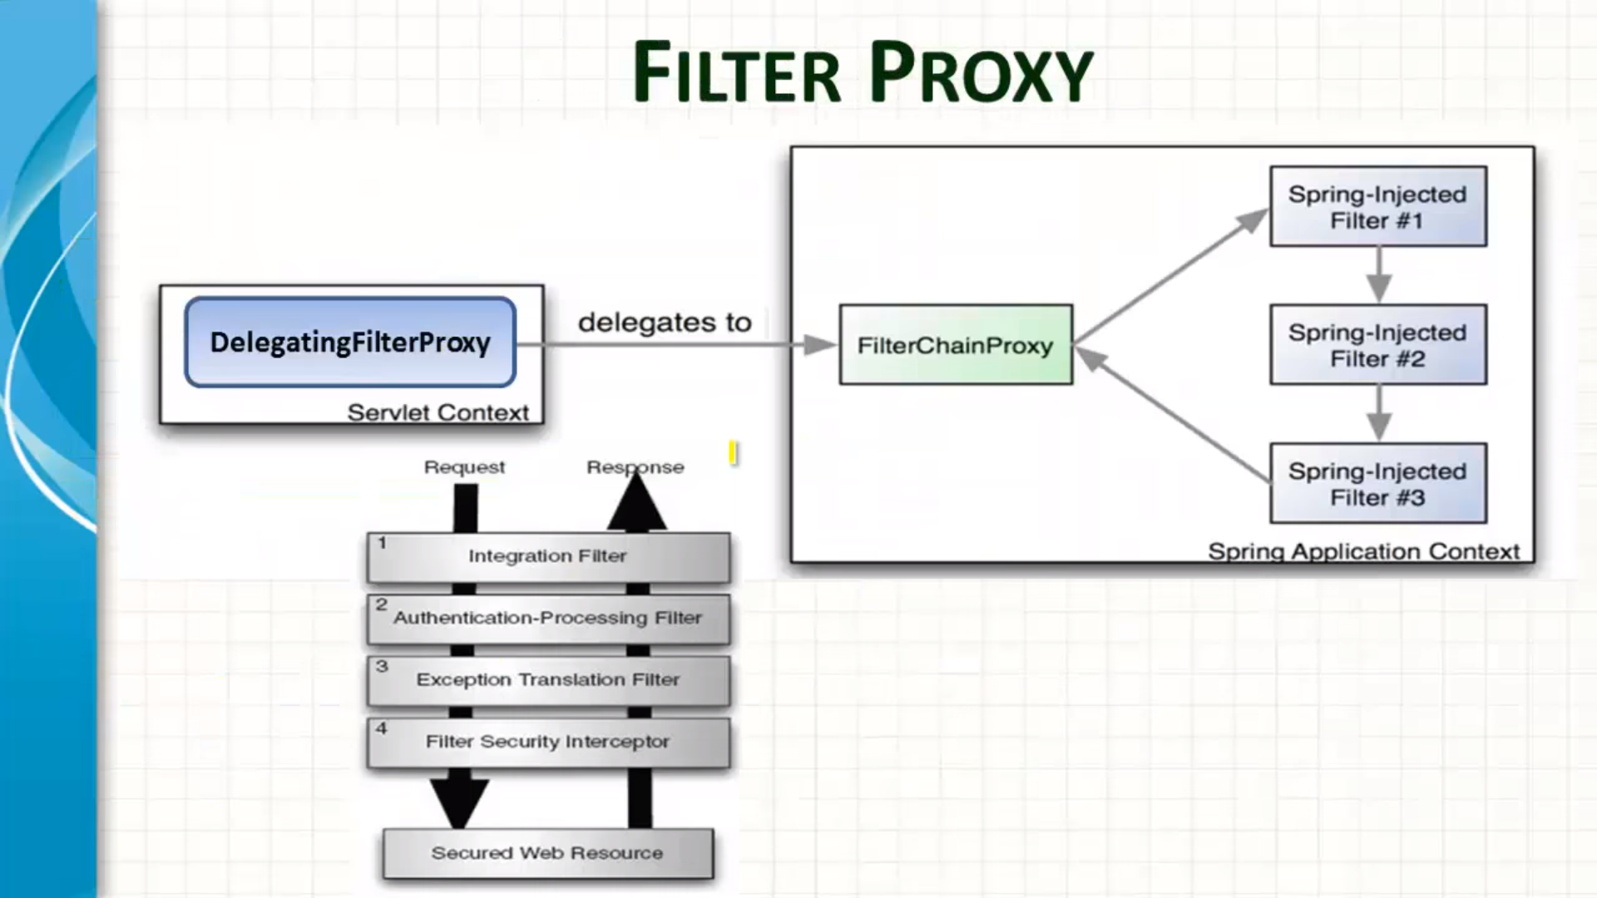

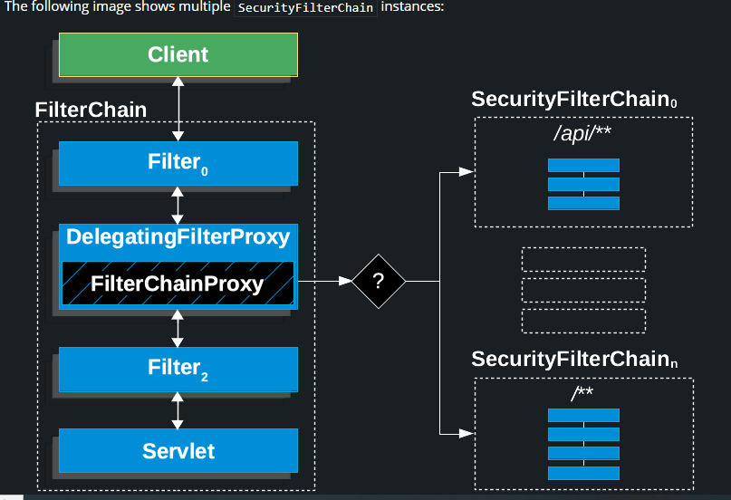

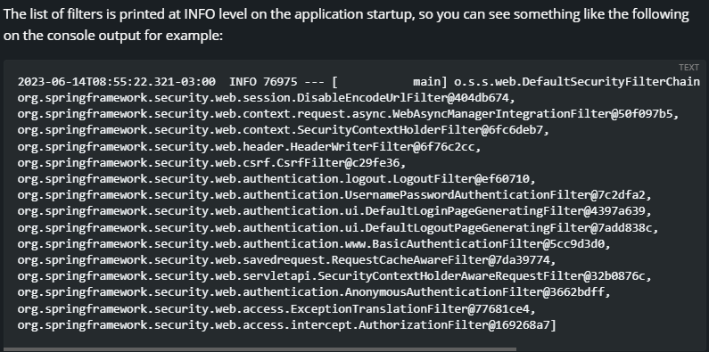

**How to register custom filter**

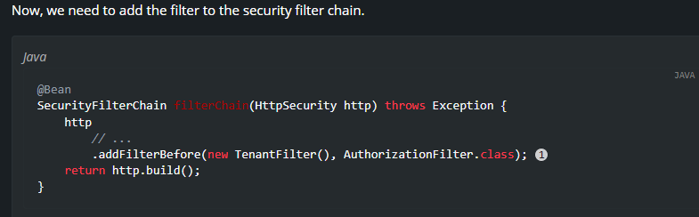

Be careful when you declare your filter as a Spring bean, either by annotating it with @Component or by declaring it as a bean in your configuration, because Spring Boot will automatically register it with the embedded container. That may cause the filter to be invoked twice, once by the container and once by Spring Security and in a different order.

@Bean

public FilterRegistrationBean<TenantFilter> tenantFilterRegistration(TenantFilter filter) {

FilterRegistrationBean<TenantFilter> registration = new FilterRegistrationBean<>(filter);

registration.setEnabled(false);

return registration;

}

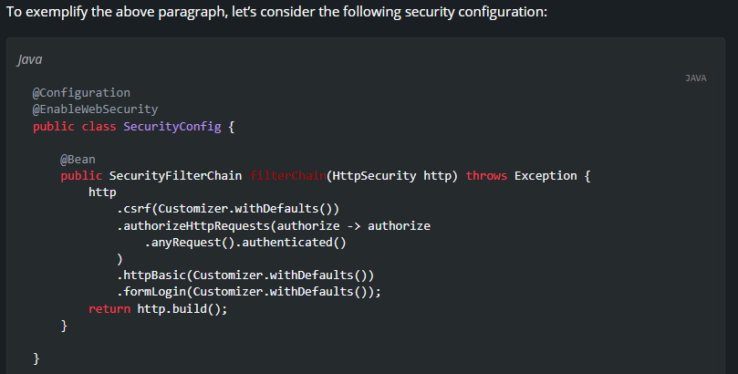

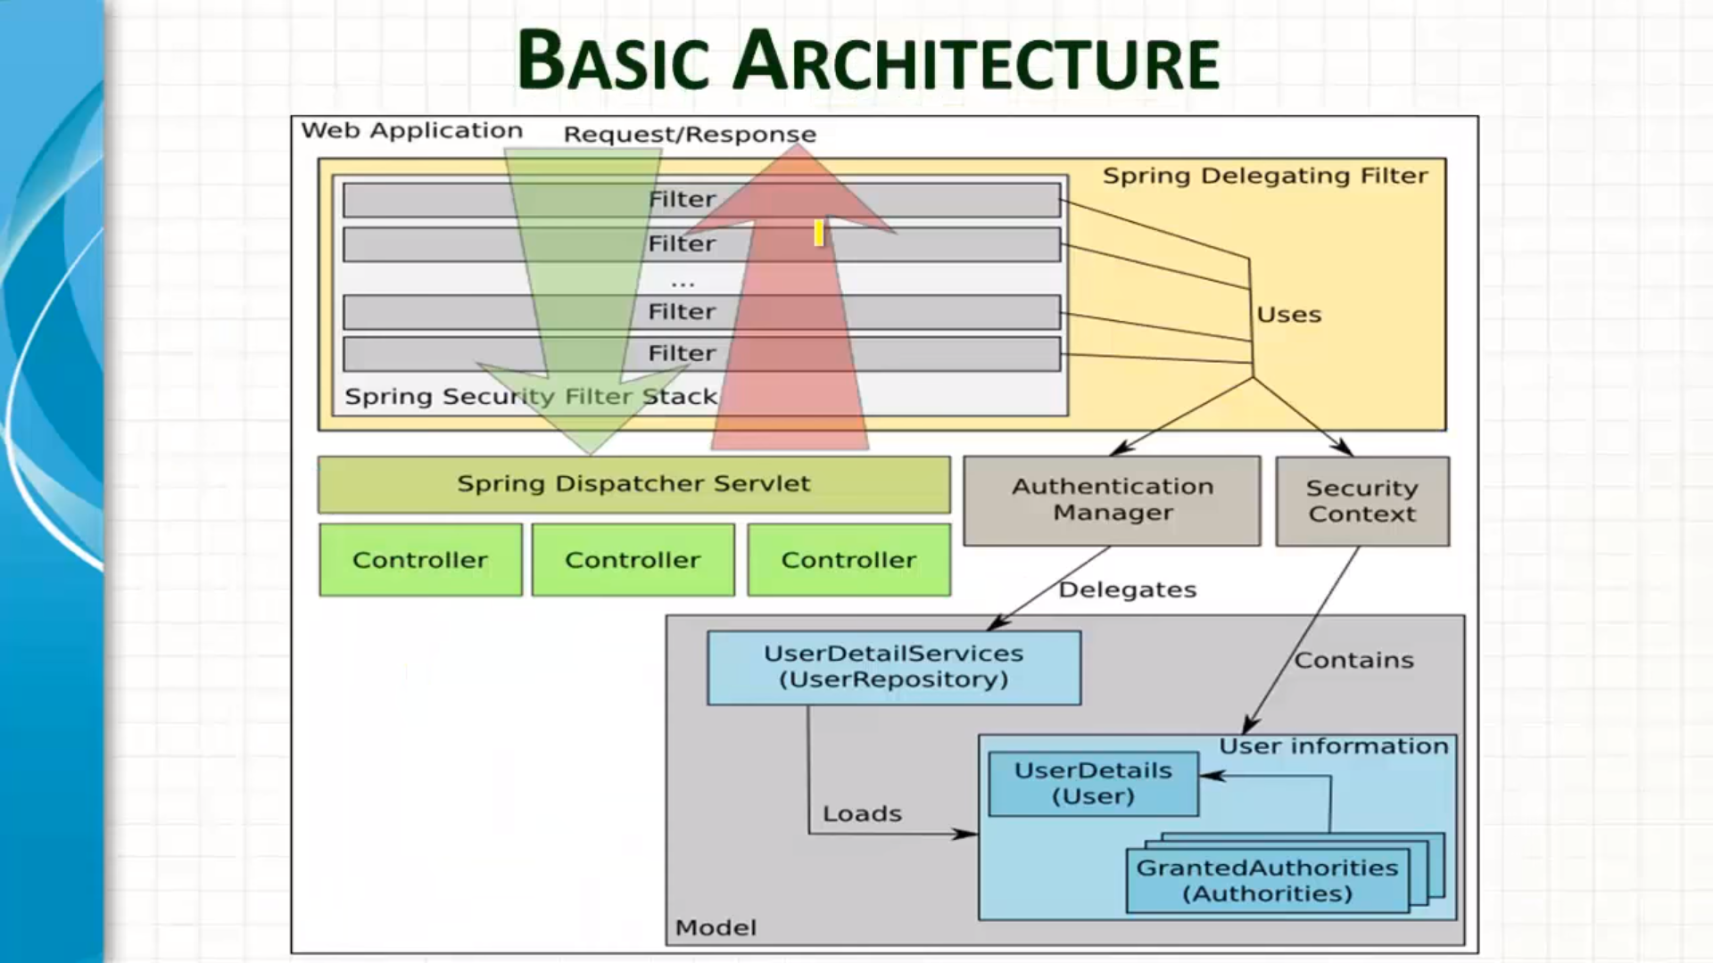

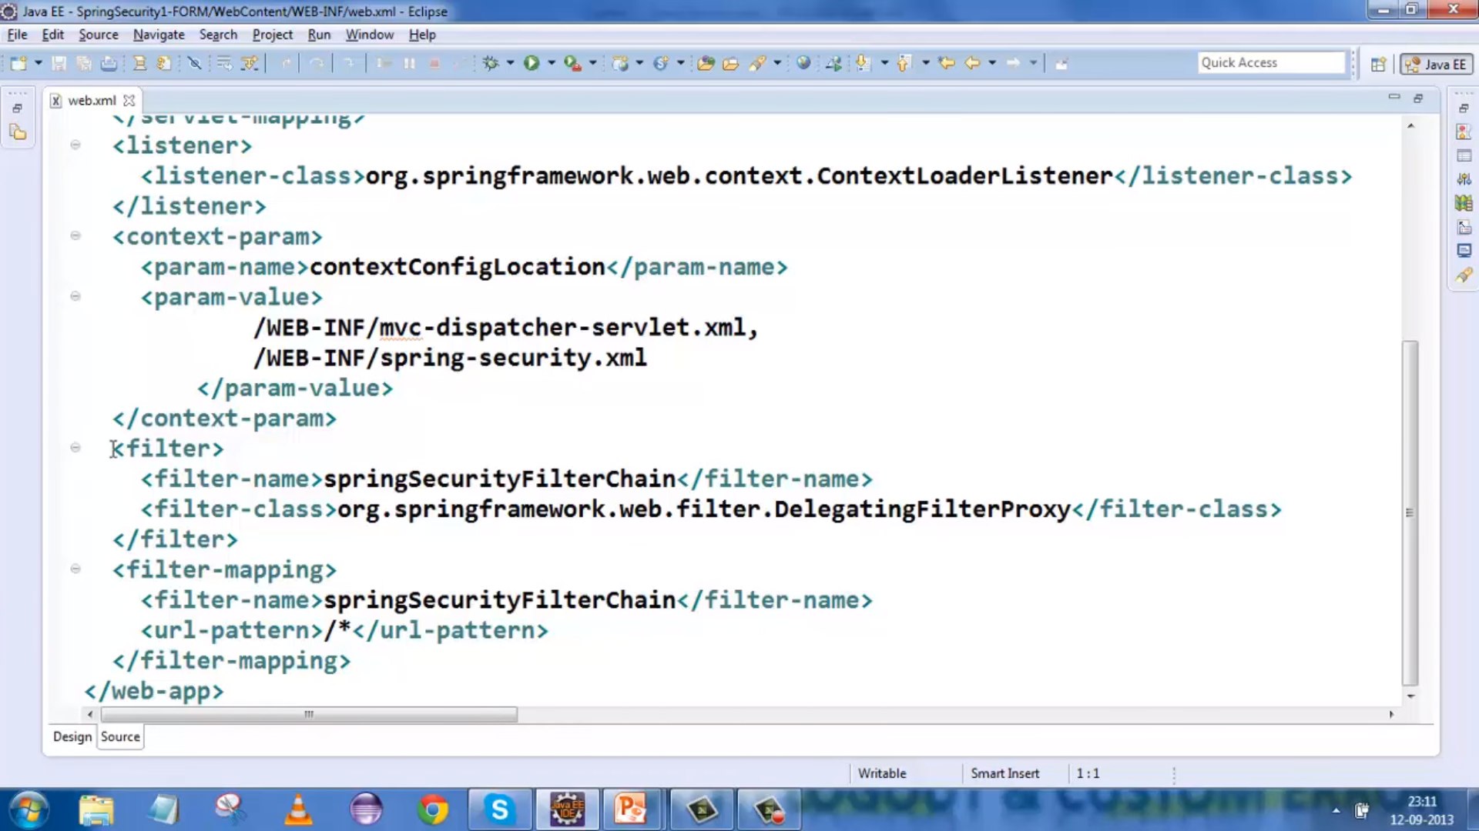

Basic & Form Security :

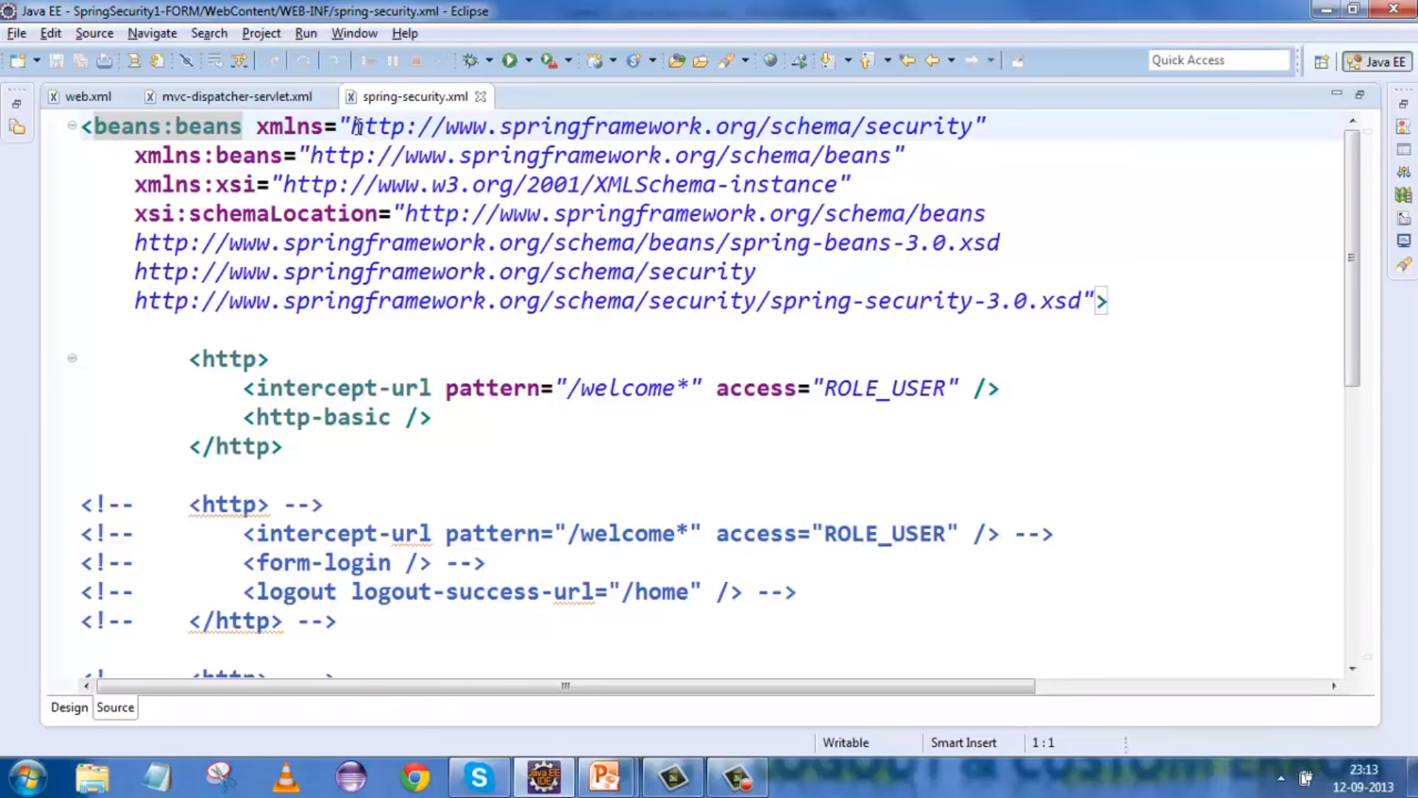

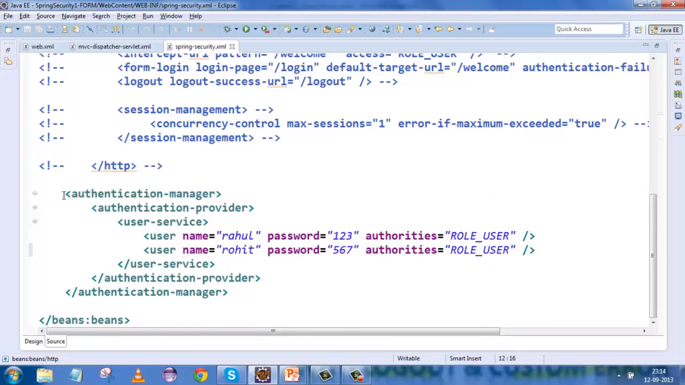

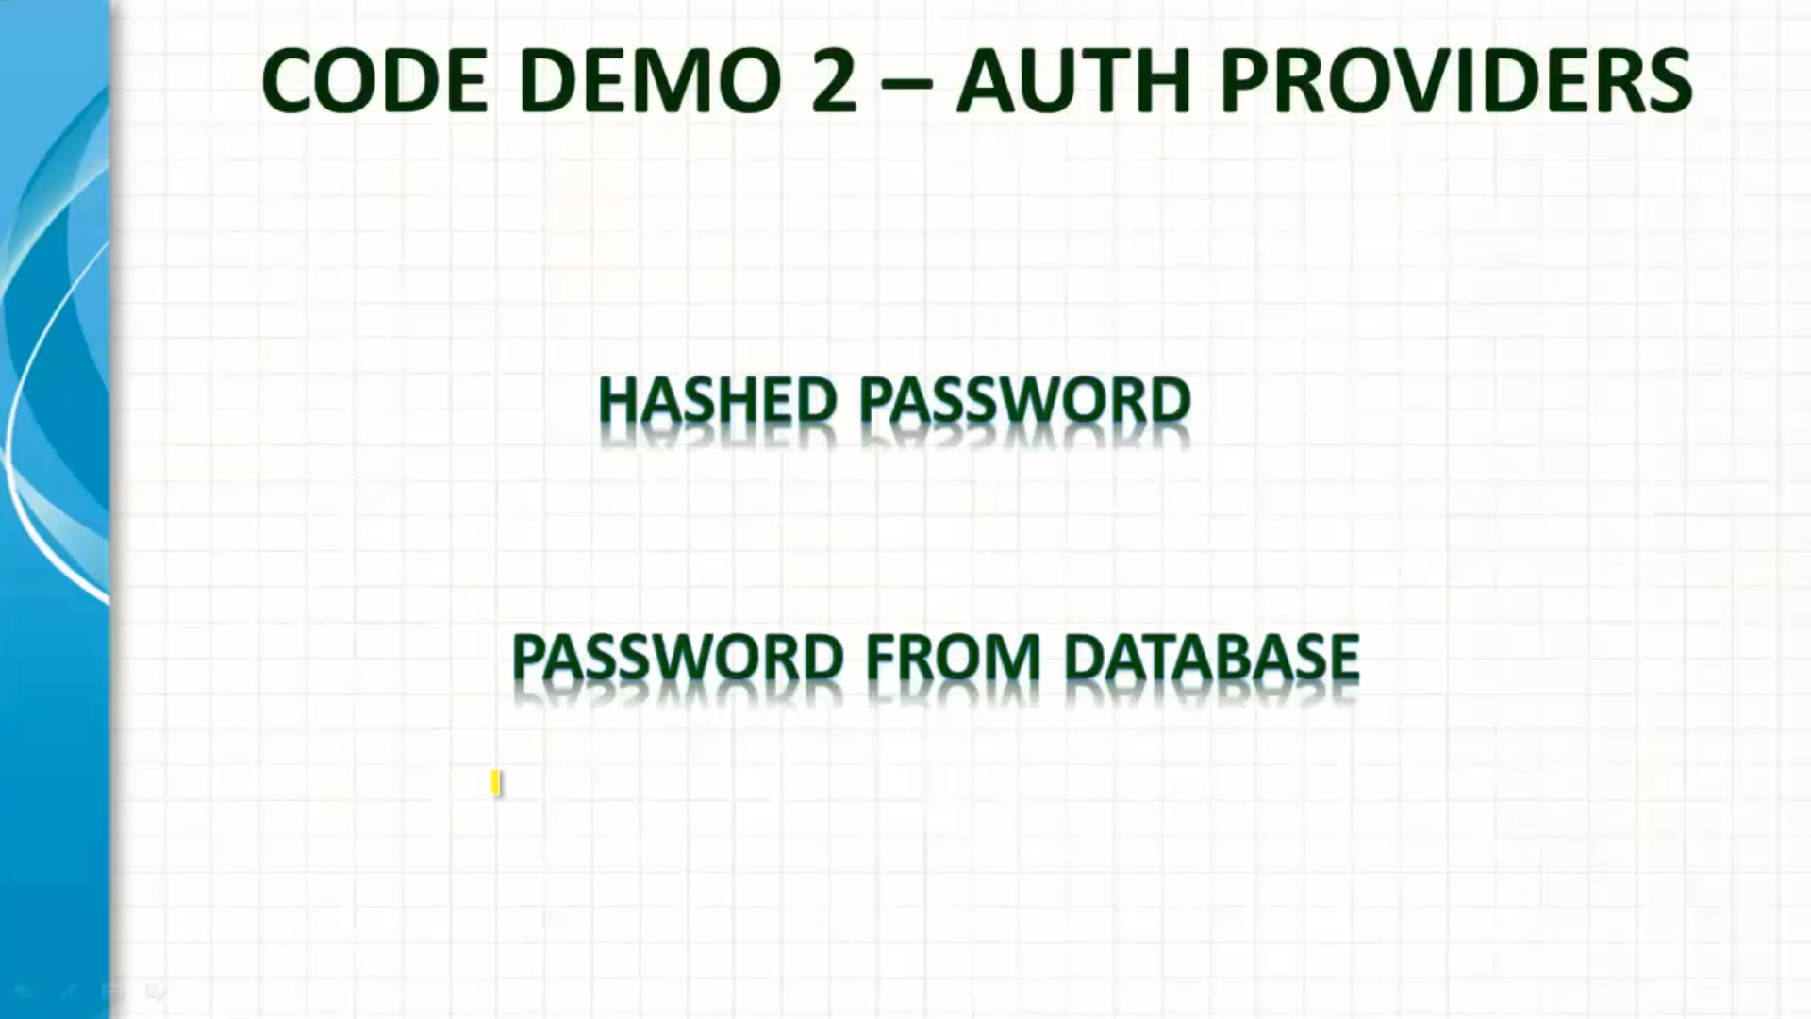

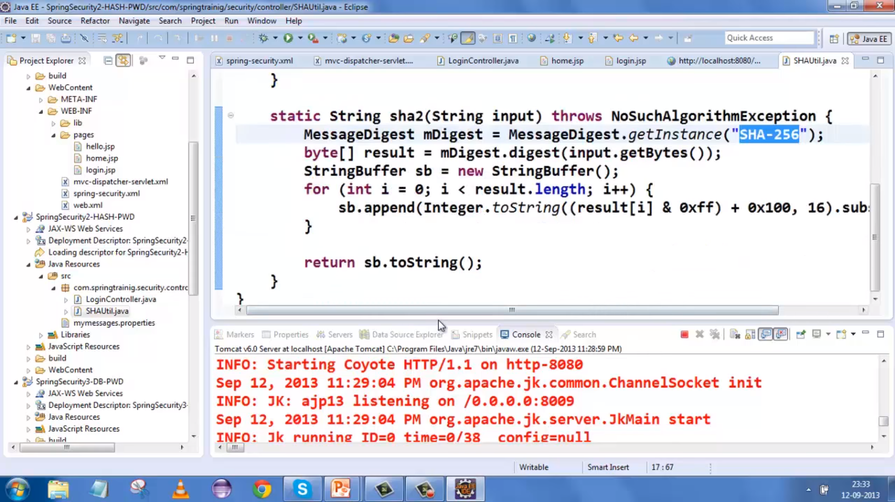

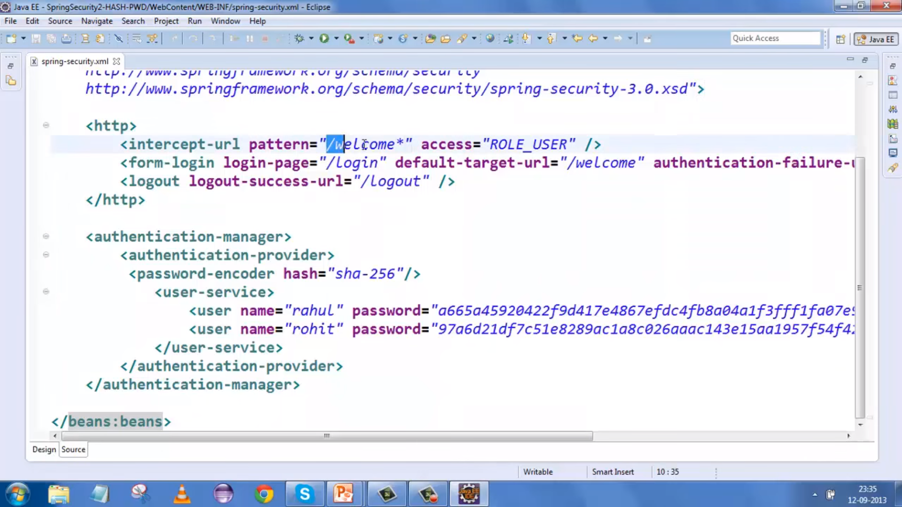

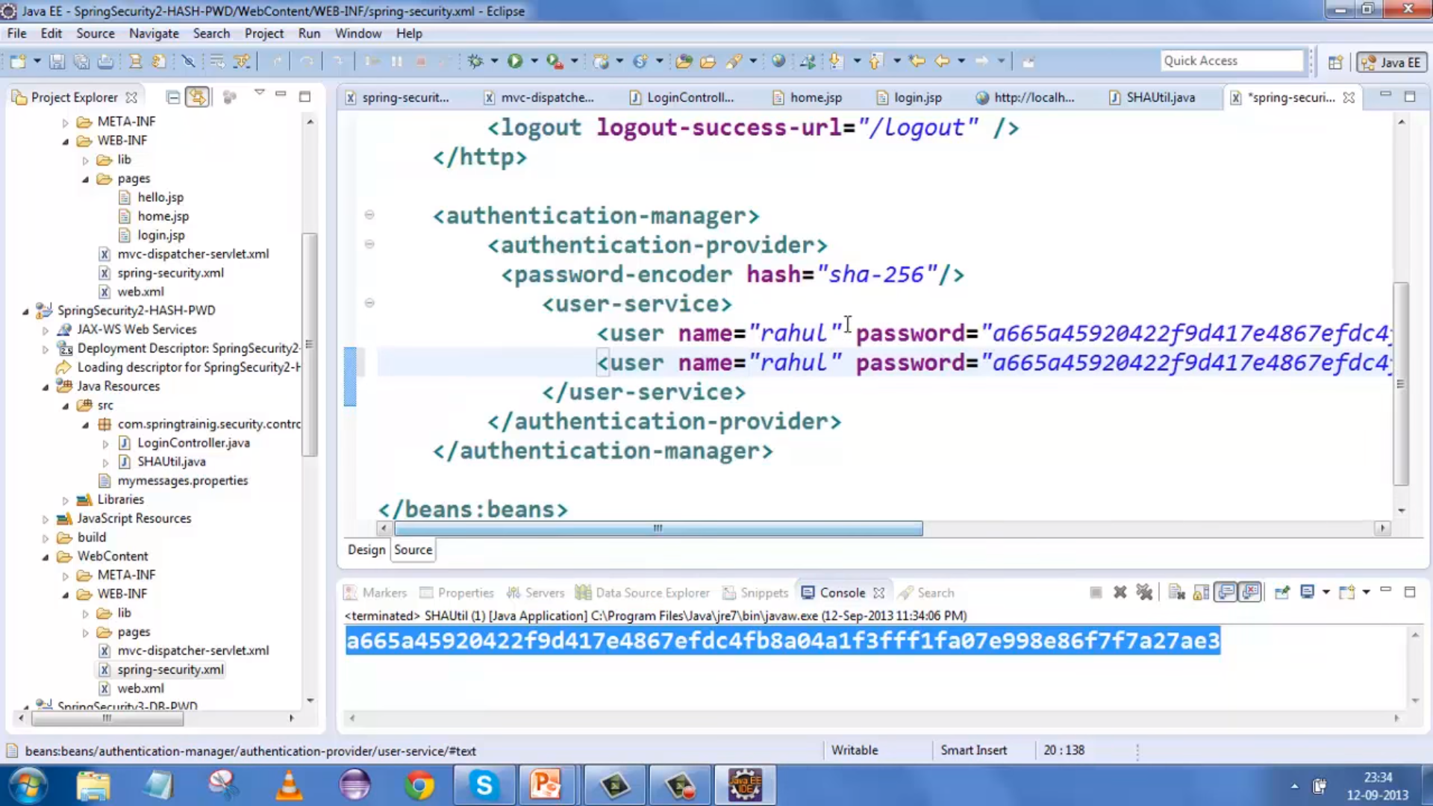

User Name & PWD from DB :

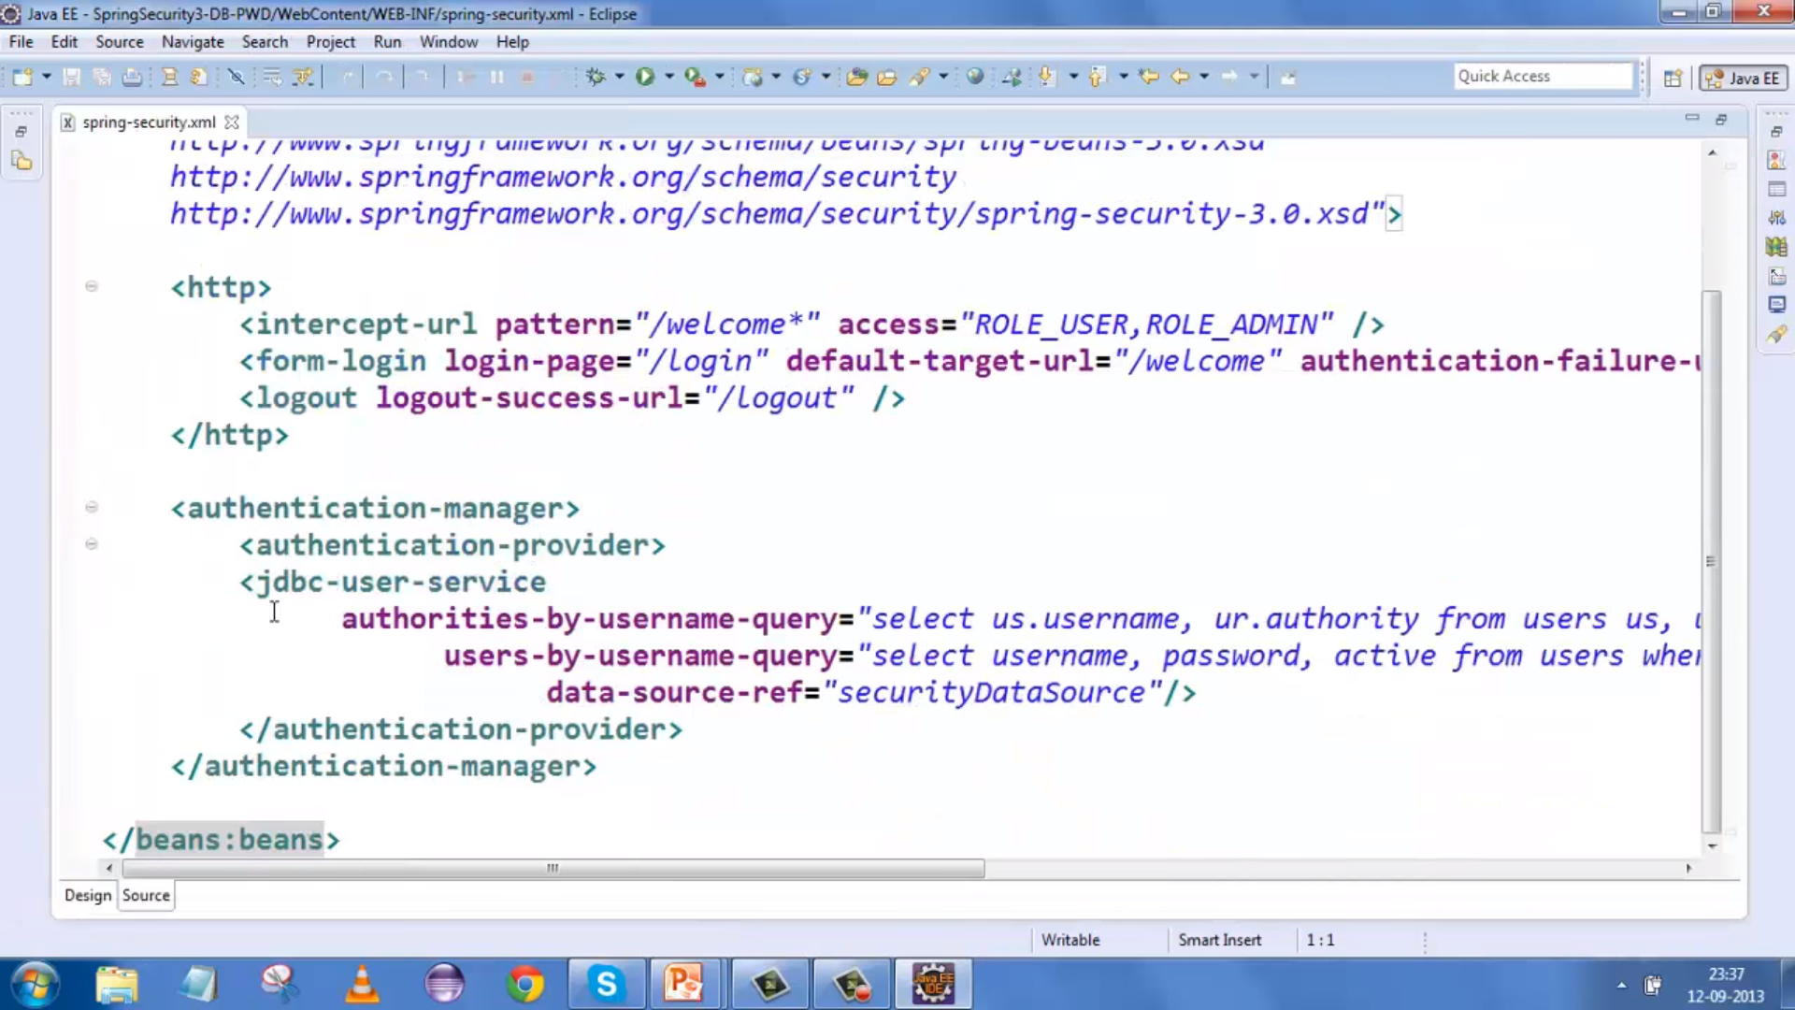

Authorization :

